**MECE 5397**

**Scientific Computing for Mechanical Engineers**

**Project A – Poisson Equation (APc1-1)**

**Ujjwal Oli**

**1240266**

**Technical Specification of the Computer Used**: MacBook Pro

**Abstract:**

This project report contains application of Gauss-Seidel numerical scheme and its offshoot “over-relaxation” scheme to solve the given partial differential equation. The scheme employs initial guesses and then iterations are performed to find the refined solutions for the problem. The solutions are iterated every time the refined solutions do not meet the error criteria defined by the solver. This method can also be called as a method of successive replacement

Numerical discretization of mathematical problem is stated in the first part of the report. Then a thorough description of algorithm and how this is used to write the code is presented in the following section. The last half of the report contains verification and the presentation of the report. The presentation of the results contains grid dependence test and the graphs/tables for the results using assigned grids.

**Discretization of Problem:**

The problem is discretized using finite difference method, as it is easy to implement and execute. The problem in consideration is stated as following.

$$\frac{∂^{2}u}{∂x^{2}}+\frac{∂^{2}u}{∂y^{2}}=-F(x,y)$$

The function on the right hand side of the stated Poisson equation is following.

$$F\left(x,y\right)=cos\left(\frac{x+2π}{2}\right)*sin\left(\frac{2y+π}{2}\right)$$

The domain of interest is described by the following rectangle.

$-π<x<π$ And $-π<y<π$

The rectangle’s boundaries are described by three Dirichlet conditions on top, bottom and left side whereas the right side of the rectangle is described using Neumann condition. The boundary conditions represented below have been simplified using available data from the problem.

Top boundary condition: $u\left(x, π\right)= {(π-x)}^{2}*cosx$

Top boundary condition: $u\left(x, -π\right)= {(π-x)}^{2}*x$

Left boundary condition: $u\left(-π, y\right)= -4π^{3}+2*\left(y+ π\right)* (π-1)$

The Neumann condition on the right side of the rectangle of interest:

$${\left.\frac{ ∂u}{∂x}\right|}_{x=π}=0$$

The Taylor series expansion has been applied to the above problem to obtain a two dimensional computational grid as stated below. The representation of the grid obtained using the equation below is shown in figure 1.

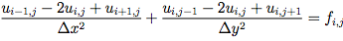

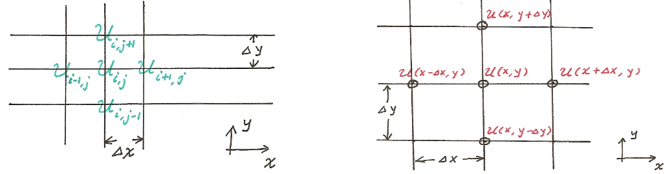

Figure : Visualization of the equation.

The discretized equation necessary for computation of the inner nodes is depicted below.

$$u_{i,j}=\frac{-1}{\left(2/∆x^{2}+2/∆y^{2}\right)}\left(-F\left(x_{i},y_{j}\right)-\frac{1}{∆x^{2}}u_{i-1,j}-\frac{1}{∆x^{2}}u_{i+1,j}-\frac{1}{∆y^{2}}u_{i,j-1}-\frac{1}{∆y^{2}}u_{i,j+1}\right)$$

The unknowns are strictly located at the interior of the grid described by the above finite difference approximation form. Below is the representation of the solution grid for the unknowns for the given problem.

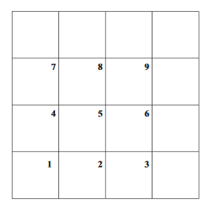

Figure : Discretization grids for the Problem.

The unknown function U is represented as a 4 by 4 grid for the convenience. The boundary conditions are placed on the outermost nodes around the above square represented by dots. For this specific problem, the Dirichlet conditions are placed on the right, top and bottom of the square.

The Neumann condition, on the other hand has been implemented using the technique of ghost nodes.

$\frac{u_{n+1}-u_{n-1}}{2h}=v$

The method provides us higher order of accuracy for better convergent solution.

Since $v=0$ for the given problem,

$$u_{n+1}=u_{n-1}$$

$u_{n-1}$ $u_{n}$ $u_{n+1}$

The above representation of the ghost nodes for the Neumann condition has been used to obtain the following equation applicable only at the specified boundary condition.

$$u_{i,j}=\frac{-1}{\left(2/∆x^{2}+2/∆y^{2}\right)}\left(-F\left(x_{i},y_{j}\right)-\frac{2}{∆x^{2}}u_{i-1,j}-\frac{1}{∆y^{2}}u_{i,j-1}-\frac{1}{∆y^{2}}u_{i,j+1}\right)$$

Description of the Algorithm Used:

The code to solve the discretized mathematical equation was generated on Mat lab. The thought process involved in solving the equation has been represented below in the Pseudo code.

Pseudo code:

* Define the four corners of the Domain.
* Input M and N for the number of internal nodes.
* Create a solution U.
* Create a 2D matrix for F.
* Create associated Dirchilet boundary conditions.
* Set up increments along x and y direction.
* Define multipliers based on the increments and the discretized equation.
* Apply Dirchilet boundary conditions to solution grid U.
* Define an error guess.
* Turn on the clock.
* Set up an iteration counter.
* Set up an error limit inside a While loop.
* Set up Neumann condition
* Solve for U.
* Calculate the error.
* Repeat until error limit is satisfied.
* Get the required plots.
* Turn the clock off.

Presentation of the Results:

This section contains the results of the simulation performed using different number of grids within the predefined limits of the solution square used. The first part of the report contains the simulations for Gauss Seidel and the last part contains simulations for Successive Over Relaxation.



Figure : Surface and Contour Plot for Gauss Seidel

The following tables represent total time taken and number of iterations performed before the solution satisfied the defined relative error.

Table : Performance of the code for different grids Gauss seidel

|  |  |  |
| --- | --- | --- |
|  | Gauss-Seidel |  |
| Grid # | Iterations | Time(s) |
| 32*32 | 1670 | 0.677309 |
| 64*64 | 4096 | 2.242268 |
| 128*128 | 16384 | 26.18 |
| 256*256 | 65536 | 394.25993 |

Table : Performance of the Over-relaxation code for lamda=1.75

|  |  |  |
| --- | --- | --- |
|  | Lamda = 1.75 |  |
|  | Over-Relaxation |  |
| Grid # | Iterations | Time(s) |
| 32*32 | 1024 | 0.13992 |
| 64*64 | 4096 | 0.471926 |
| 128*128 | 16384 | 5.690458 |
| 256*256 | 65536 | 94.210424 |

As it is clearly evident from the above two tables that Over-relaxation algorithm is faster than the Gauss-seidel without over relaxation. Both the algorithms have been plotted in the following figure for same amount of grid numbers.

Figure : TIME V/S grid length plot.

This section of the result includes the iteration performance for the given equation when F=0.



Figure : Surf and Contour for F=0.

The following table depicts the iteration number and speed performance for Successive over relaxation method when F=0.

Table : F =0, Over relaxation performance method.

|  |  |  |
| --- | --- | --- |
|  | F=0 |  |
|  | Over relaxation |  |
|  | lamda=1.75 |  |
| Grid # | Iterations | Time(s) |
| 32 | 1024 | 0.111434 |
| 64 | 4096 | 0.462516 |
| 128 | 16384 | 5.654559 |
| 256 | 65536 | 97.306009 |

**Verification and Validation:**

To verify the convergence of the algorithm, maximum value on the column of the Neumann condition was found for each of the different grids applied. The result produced by the code was not consistent so the convergence of the code was not verified. There were various attempts to fix the code but could not be done. The first attempt on writing the algorithm was by setting up a penta-diagonal method but it was deemed unsuitable by the instructor. The time constrained prevented me from verifying the code.

References:

<http://www.public.asu.edu/~hhuang38/pde_slides_numerical_laplace.pdf>

<http://www4.ncsu.edu/~zhilin/TEACHING/MA402/chapt5.pdf>